CHAPTER ONE
1.0 INTRODUCTION
1.1 BACKGROUND OF THE STUDY
The water alarm detector is a self-contained electronic device that sounds an alarm when its sensor is in contact with water. It can be used near water heaters, washing machines, sump pumps, bathtubs, toilets, dishwashers, and high-efficiency furnace pumps. Water alarms will detect leaks from toilets that have the potential to cause mold growth [1] O. J. Bedrij.
Slow leaks from appliances and plumbing fixtures often go unnoticed. Excess moisture and standing water from a slow leak can cause extensive damage to the floors and walls of your home. There is also the potential for mold growth. A water alarm detector will let you know if there is a moisture problem.
There are two types of water alarm detectors-passive and active. The passive detector uses a 9-volt battery. The moisture sensor is placed on the floor and activates the alarm when it becomes wet. Damp locations or high temperatures may reduce the life of the battery, so the detector should be checked regularly to see if it is working properly. These detectors can be purchased at most home improvement stores. [2] B. Ramkumar, H.M. Kittur, and P. M. Kannan.
Active water detector systems can operate an individual appliance or control the whole house. This system also generates an alarm, and it automatically shuts off the water supply. These systems are more costly than passive systems.
Since active water detectors may require special shut-off valves and electrical wiring, it is best to consult a professional to determine which system will meet your needs.
1.2 PROBLEM STATEMENT
People often forget to lift the suspension of clothing during the day which exposes their clothes to rain which makes their clothes to take longer time to dry. Most especially people who are working or doing business, they don’t worry about their clothes that have been dried outside. This device brings solution to this problem. This project develop for working couple or busy people, it gives an indicator of rain drop via alarm.
1.3 AIM AND OBJECTIVES OF THE PROJECT
It be will rain at any time without realizing it. Shirts in a clothesline outside the house that is almost dry to wet again if we are slow to lift it. This project will help the housewife or other users to alert more quickly when it rains. The sensor is able to detect even the slightest water and will sound an alarm when exposed to rain. The main objective to be achieved in this project is to produce an alarm to help users alert more quickly to avoid the presence of rain from wet shirt at clothesline outside the house. Sub objective that support the main objective are:
1) Complete the electrical circuit to detect the presence of rain
2) Complete the mechanical part of the model house
1.4 METHODOLOGY
BLOCK DIAGRAM OF THE SYSTEM
The block diagram of the system in fig 3.1 shows the link or interconnection between the basic blocks of the system. [3] T. Y. Ceiang and M. J. Hsiao.
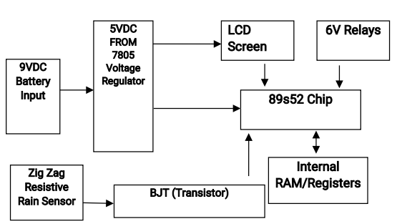
Resistive Rain Sensor
555 Timer

1.5 SIGNIFICANCE OF THE PROJECT
A rain sensor is an automated device that shuts off your lawn irrigation system every time it rains. It is a relatively cheap device that can save up to 45 percent of your water bills, help protect the environment and conserve water.
A rain sensor is mounted outdoors away from trees and roof over hangs so that it can collect rainwater without obstruction. A rain sensor can either be wired or wirelessly attached into a lawn irrigation system. Below are the five advantages of using a rain sensor.
1. Conserve Water
There is a lot of water that you can save by using a rain sensor. By automatically turning off your lawn irrigation system every time it rains, the conserved water can be used in other essential purposes such as fighting fire.
2. Prevent Disease Damage and Nutrient Loss
A lawn irrigation system equipped with a rain sensor minimizes wasteful runoff such as pesticides, motor oil, fertilizer, pet waste and sediments from reaching your waterways. It also minimizes garden pollutants such as herbicides and fertilizers from getting into your groundwater system.
Over-watering prevent the roots of your plants from reaching deep into the ground making your plants vulnerable to disease. Over-watering is also one of the major cause of nutrient loss in plants as excessive watering washes away the nutrients of the soil leaving your plants weak and unhealthy.
3. Save Money on Fertilizer
A rain sensor prevents you from overwatering your plants and lawn. When a plant is overwatered, the nutrients from the turf wash away into the drainage system. You have to compensate by adding more fertilizers to your lawn and plants. This means spending more money on fertilizers. With a rain sensor that effectively prevents your lawn irrigation system from overwatering your lawn and plants, your garden turf will remain to be an ideal environment for your plants in accordance with the fertilizer that you are using. [4] J. M. Rabaey.
4. Increase the Life-span of your Irrigation System
Using a rain sensor prevents unnecessary wear and tear of your lawn irrigation system since it minimizes the amount of time that your lawn irrigation is in operation. This is especially useful during the rainy season where rain unpredictably come and go.
5. Prevent Groundwater and Waterways Pollution
APPLICATION OF THE PROJECT
Rain alarm is an application which detects the rain water and blows alarm. They are useful devices and play an important role in various industries such as automobile, irrigation, and wireless communication.
1.6 SCOPE OF THE PROJECT
This rain detector will give you a heads-up the instant it starts to rain, hopefully giving you time to close windows and bring in possessions. The circuit draws virtually no current when the sensor is dry and the current consumption is low when the buzzer is activated. Alternately, a molded power supply with a simple voltage regulator to drop the voltage to 3 volts could be used. When the circuit is triggered, the buzzer is pulsed about once per second for a very short time, giving it a "dripping water" sound which seems appropriate.
1.7 REPORT OUTLINE
The various stages involved in the development of this project have been properly put into five chapters to enhance comprehensive and concise reading. In this project thesis the project is organized sequentially as follows:
1. Chapter one of this work is basically the introduction to rain sensor. In this chapter; the background, motivation, aim, significance of study etc was discussed.
2. Chapter two was based on the literature review of rain alarm. In this chapter, all the literature relating to this work was surveyed.
3. Chapter three describes the methodology and the architectural aspect aspect of the rain sensor.
4. Chapter four itemizes the test analysis and results therein.
5. In Chapter five, the conclusion and recommendation of the work was given.
TYPES OF WATER ALARMS
It’s a full time job keeping your basement dry. Everyday threats include heavy rains, backed up sewage line, a leaky hose or even your neighbour emptying their pool. Sump pumps are perfect for removing pooling water, and a backup battery and pump system help create peace of mind. Even with a backup pump and battery system, failures happen.
It’s the water sensor and alarm system that act as your last line of defense; alerting you before disaster strikes. In this post we’ll explore four different options of water alarms: the standard alarm, the phone dialler (or auto-dialler) alarm, the Wi-Fi enabled alarm, and the cellular sump pump alarm.
Standard Sump Pump Alarm. The most cost-effective solution on the list is this group of sump pump alarms. They are very simple and have a limited feature set. For the user, just set the device on the floor and when water is sensed the alarm will sound. Some standard alarms work via battery power, some via a wall outlet, and some offer a wall plug with battery backup.
Pros: very affordable, easy setup, great if you’re going to be in close proximity of the unit to hear it.
Cons: rely on proximity, if you’re not close or can’t hear the alarm then you’re not being warned. Cheaper units use low quality parts that may rust overtime, rendering them useless.
Phone or Auto Dialer Sump Pump Alarm. The auto dialer alarm works much like the standard pump alarm; when water is sensed the device sounds an audible alarm. The auto dialer has an added feature though; it can make a call out to your phone to warn you of the alarm. The only way the call out feature works is when a phone line is present at the device, this could mean installing a line in the basement or having to run service to your home if you only use a cell phone for phone service, which is rather common these days.
Also, if there is a lightning strike, the surge will come in thru the unshielded phone wire and take-out the dialer. You usually don’t know it happened until you need the dialer, and it does not work. Also, sometimes dialers will not hang-up the phone line, disabling all the phones in your house. If this happened during an emergency, people calling your house will get a busy signal, and you have no idea what is happening;
Pros: calls to send alerts rather than just sounding an alarm, ensures you know there is a problem.
Cons: can run rather expensive at prices near, could be difficult to install if you do not already have a phone line running to your sump pump, could cost you long distance depending on where you’re calling, may be rendered useless by lightning, may not hang up and jam up your outgoing phone connection.
WiFi Auto Dialler Water Alarm. The solution for installing a phone line is the Wi-Fi based sump pump alarm. The solution works just like the Auto Dialler in that the device will call you when it senses water. The one perk is that you can connect to your local wireless network and it will use VOIP (Voice Over Internet Protocol) to send the call. Some of these devices also allow remote data monitoring and the sending of emails or SMS messages.
If you do not have a wireless router or internet connection, then this will not be the right solution for your use. Also, unless your cable router and Wi-Fi access point are backed-up on a UPS (uninterruptible power supply), your Wi-Fi access point will be powered off during a power-fail event and will not be able to notify you of an alarm.
Pros: added features since it’s an internet connected device, no need to run phone lines to the alarm
Cons: rather expensive with most systems starting at greater than $300, could be difficult to install if you’re not familiar with wireless networks, must have a wireless internet connection for this system to work, must have a UPS system or you won’t receive notifications when power is lost to your home Oyubu A.O, (2017) [1].
Cellular Sump Water Alarm. These are the newest devices on the market and work like the standard sump pump alarm and sound an alarm when water is sensed. Since they are cellular based they have text messaging built in and send out a message when the water sensor touches water. These devices do not require a phone line or wireless internet connection to work, but do generally require a cell service plan. Some cellular water alarms come bundled with the cellular card and are truly plug-in-play, others require a separate cell phone or dedicated-pre-pay phone that connects to the unit, making it a little more difficult to setup. Cellular water alarms are the easiest to install systems that offer their particular features [5] J. M. Rabaey. They install like a standard pump alarm but offer the features of more robust and harder to install systems.
Pros: easy to install, very cost effective, offer two notifications in the form of an audible alarm and a text message.
Cons: require cell service which is available just about everywhere but some spots do not get coverage. Choose the Right Technology. In the end, it does matter what technology you use. You’ll want water alarm that:
Alerts you no matter where you are, because leaks and floods can happen any time of day or night.sends messages when the power goes, as power is regularly knocked out during a storm.
sends notifications direct to your mobile device, so you can take immediate action to prevent a flood.

References
[1] O. J. Bedrij, “Carry-select adder,” IRE Trans. Electron. Comput, pp. 340–344, 1962.
[2] B. Ramkumar, H.M. Kittur, and P. M. Kannan, “ASIC implementation of modified faster carry save adder,” Eur. J. Sci. Res., vol. 42, no. 1, pp.53–58, 2010. [3] T. Y. Ceiang and M. J. Hsiao, “Carry-select adder using single ripple carry adder,” Electron. Lett., vol. 34, no. 22, pp. 2101–2103, Oct. 1998.
[4] J. M. Rabaey, Digtal Integrated Circuits— A Design Perspective Upper Saddle River, NJ: Prentice-Hall, 2001
[5] J. M. Rabaey, Digtal Integrated Circuits— A Design Perspective Upper Saddle River, NJ: Prentice-Hall, 2001.

CHAPTER TWO
LITERATURE REVIEW
2.1 THEORIES OF RELATED WORK
A rain sensor is a rainfall triggered device. Some applications of rain sensors are; first, connecting the device to automatic irrigation system to make the system shut down by sensing rain drop. The second is a device used to shield the interior of automobiles from rain and to support the automatic mode of windscreen wipers. An additional application in professional satellite communications, antennas are used to trigger a rain blower on the aperture of the antenna feed to remove water droplets from the Mylar cover that keeps pressurized and dry air inside the wave-guides.
Rain sensors for irrigation systems are available in both wireless and hard-wired versions most employing hygroscopic disks that swell in the presence of rain and shrink back down again as they dry out — an electrical switch is in turn depressed or released by the hygroscopic disk stack and the rate of drying is typically adjusted by controlling the ventilation reaching the stack. However, some electrical type sensors are also marketed that use tipping bucket or conductance type probes
to measure rainfall [6] Y. He, C. H. Chang, and J. Gu. Wireless and wired versions both use similar mechanisms to temporarily suspend watering by the irrigation controller — specifically, they are connected to the irrigation controller's sensor 1011 terminals or installed in series with the solenoid valve common circuit such that they stop the valve from opening when rain has been sensedsense.
Where irrigation systems are still used over the winter, some irrigation rain sensors also contain a freeze sensor to keep the system from operating in freezing temperatures.
HISTORICAL OVERVIEW OF RAIN SENSING DEVICES
One of the oldest type of rain sensor still in use today has a water collecting basin that performs the work of a rain guage [7] Cadence. Once the basin collects a pre-set amount of water, the weight of the water trips a switch and triggers the irrigation system off. The challenge with this type of rain sensor is that the basin doesn't discriminate between rain and debris which can fill the container and interrupt the watering cycle untimely. Some of the wider basin types allow wind to blow rain water out of the container which delays the shut-off. [8] Oyubu A.O, (2017). Conductivity is the principle of the second generation of rain sensor. Two electrodes are positioned a certain distance from the bottom of the basin. When the water level reaches the electrodes, a circuit is completed and the switch is triggered. The weight of debris will not trigger the switch but displaces water causing the untimely switching of the trip during a brief shower.
The open container is the liability with either of the first two rain sensor types.
The third and currently most popular sensor discards the old catch basin. A hygroscopic disk made of a synthetic material similar to cork expands when it gets wet. The more it gets, the more it expands. The expanded disk triggers the switch after a preset amount of rain has fallen. There is a continuous expansion as more rain fall. Until the disk dries out and returns to normal size, the system will not resume schedule. The sensor keeps preventing water as more rain fall.
2.2 REVIEW OF RELATED LITERATURE
For quite some years ago till date, many works on Rain water detection have been done by electronic engineers. [9] Hashim N.M.Z, Husin S.H, Ja’afar A.S & Hamid N.A.A, (2013). These works range from collecting rain water for domestic and industrial use a process known as rain water harvesting, the application of rain detector circuit/device in irrigation to using rain detector/Sensor in automobiles to serve as a control for the power windows and roof whenever it senses moisture, a design known as automatic rain sensing windows.
P. Campbell in his work described that Automatic Rain sensing windows worked to create a device that will allow car windows to roll up automatically when it rains thereby preventing the interior from getting damaged. The design was essentially used with automobiles. Campbell scientific built a rain detector which functions to sense whether it is raining or snowing, and the output used to trigger another circuit on or off.
Mohammed inserted a rain detector in his work designed to gather rain water automatically and store same in reservoir for domestic use. Prabhakar Hegade, Sunil Nayak, Parashuram Alagundi and Kiran M R 121 designed a device. In their project, there are trays which opens & closes based on sun rays. Tray is fixed on roof and controlled through 8 bit microcontroller which recognizes this status of weather.
Imran Ahmed Khan and Khushboo Gupta worked on a device and the purpose of the device is to create a system that will allow car windows to roll up automatically when it rains, to prevent interior damages and to make device conducive for users. The aim is developing a reliable automatic rain detection system that is commercially available to a large market of automobile users.
GAP IN LITERATURE
This work is unique in the sense that it does the work of the user whether he/she is present or not. It doesn’t even need alarm to inform people or the users of rainfall and it does a general job. The microcontroller is delayed by some seconds to enable the motors delay before moving the protector open or close to save the life of the device. The project was designed to solve the problems stated. [10] Rain sensor https//www.azosensors.com/lietraure -category. aspx?cat=34.

Reference
[6] Y. He, C. H. Chang, and J. Gu, “An area efficient 64-bit square root carry-select adder for lowpower applications,” in Proc. IEEE Int. Symp. Circuits Syst., 2005, vol. 4, pp. 4082–4085.
[7] Cadence, “Encounter user guide,” Version 6.2.4, March
[8] Oyubu A.O, (2017) “design and implementation of a rain water detector-larm system ” International Journal of Advancements in Research & Technology, Vol 4, Issue 6, June .
[9] Hashim N.M.Z, Husin S.H, Ja’afar A.S & Hamid N.A.A, (2013)“ International Journal of Application Smart Wiper Control System” or Innovation in ngineering & Management Vol. 2 Pp. 409-415.
[10] Rain sensor https//www.azosensors.com/equipment-category. aspx?cat=34.

CHAPTER THREE
3.1 CONSTRUCTION METHODOLOGY
Rain Alarm Circuit
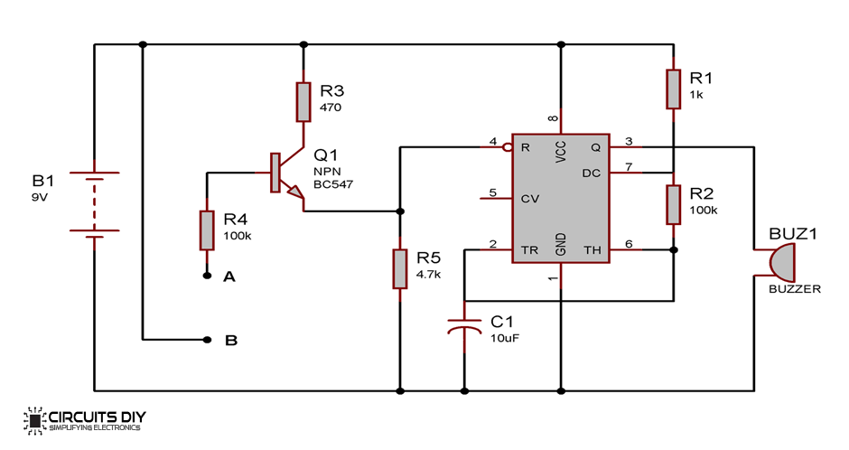
Figure 1: Rain Alarm Circuit
PROCEDURES
- Firstly insert a 555 Timer on a PCB board
- Connect another transistor Q1-BC547 (NPN) on PCB board
- Connect pin 8 to positive terminal.
- Then connect pin 1 to the negative terminal.
- Connect pin 2 to a capacitor (C1 10uf) to the negative terminal.
- Connect pin 4 to a resistor down to negative terminal.
- Then connect pin 6 and 7 to resistor (R2 and R1) to the positive terminal.
- Connect pin 3 to the positive of the buzzer.
- Then the negative terminal of the buzzer to ground.
- From pin 4 to the emitter of the transistor.
- From the collector, resistor (R3) to the terminal.
- From the base of the transistor resistor (R4) is connected to the sensor.
- Test the circuits make all connections and power up. Place a drop of water on the sensor so that two wires become shorted through water. Now the cover opens.
3.2 CIRCUIT OPERATION
A rain alarm project is a very simple and useful project. It detects the rainwater and triggers the buzzer or alarm. In this tutorial, we have designed the rain alarm circuit by using 555 Timer IC. This project gives an alarm when rainwater is detected. So that some actions can be taken for rainwater harvesting and also save the rainwater for using it later.
When the rainwater sensor detects the rain it sends the signal to the 555 Timer IC. The 555 Timer IC operates in a stable mode. This activates the buzzer for an indication of the rain.
Working Explanation
The three main components of the rain alarm project are Rainwater sensor, 555 Timer IC and a buzzer. The rainwater sensor is a simple sensor and an easy tool that detects rain. It acts as a simple switch. It remains open when there is no rain and closes when it detects the rain. The rainwater sensor is just a board of bakelite or mica with aluminum wire. [11] http://www.pic-control.com/rain-sensor, 7-April-2015. Aluminum wire is pasted on the flat board. It should be noted that there shall be no space between the wire and the board. When the rainwater sensor is completed it connects to the circuit which allows the voltage to pass through the wires. In case if there is no rain the resistance between the contacts remains very high. As the rain comes to the water drops fall on the rain sensor and forms a conductive path. This also decreases resistance between the contacts.
APPLICATION
The rain alarm project plays an important role in different industries such as automobiles, irrigation, and wireless communications.
In the irrigation, it detects the rain and alerts the farmer.
It detects the rain and actives the wiper by informing the driver in the automobiles
In communications, it boosts the power of an antenna and increases the signal strength to send or receive.
It is a very simple rain alarm circuit which is designed using mainly a transistor, water sensor and a 555 timer IC. Whenever there is a rain, rain drops falls on the rain sensor, and as you can see in the diagram of rain sensor, water on rain sensor would short the Point A and B. As soon as Point A and B become short, a positive voltage would get applied on the base of Transistor Q1, through the resistance R4. Because of the voltage at the base, transistor becomes ON (initially it was in OFF state), and current started flowing form collector to emitter. [12] , Retrieved https://learn.sparkfun.com/tutorials/transistors 6-May-2018.
Now Reset PIN 4 of the 555 Timer, gets a positive voltage and 555 timer IC becomes ON and Buzzer starts beeping. Here we should note that initially there was no positive voltage at Reset PIN 4 of 555 IC, as it was connected to the ground through resistance R5 (4.7k) and 555 IC only works when Reset pin gets positive voltage.
Here we can see that 555 Timer IC has been configured in Astable mode so that Buzzer generate a oscillating sound (means periodically on and off). This oscillation frequency can be controlled by changing the value of resistor R2 and/or capacitor C1. Pin 5 control Pin, should be connected to ground through a .01uf capacitor. Resistor R3 and R4 has been used to control the transistor’s collector and base current respectively.
Rain sensor should be kept at 30-40 degree from the ground, so that water cannot stay on it, for the long time, this will prevent the alarm to going on for a long time.

COMPONENTS DESCRIPTION
S/N | COMPONENTS | DESCRIPTION | RATE
 | Resistor | R1 | 1k
 | Resistor | R2 | 100k
 | Resistor | R3 | 470k
 | Resistor | R4 | 100k
 | Resistor | R5 | 4.7k
 | Capacitor | C1 | 10uf
 | Transistor | Q1 | BC547 (NPN)
 | Buzzer | Bzz | 12v
 | Battery |  | 9v
 | 555 Timer | IC | 555 timer
 | Vero Board
 | Switch

1. A resistor is an electrical component that limits or regulates the flow of electrical current in an electronic circuit. Resistors can also be used to provide a specific voltage for an active device such as a transistor.
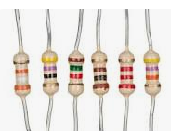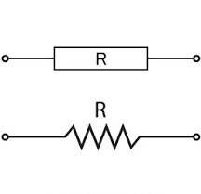
Figure 2: Resistor
2. A capacitor is a device that stores electrical energy in an electric field. It is a passive electronic component with two terminals. The effect of a capacitor is known as capacitance.
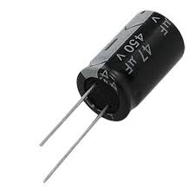
Fig3: capacitor Capacitor Symbol

3. Battery: Common applications for lithium nine-volt batteries are smoke and carbon monoxide (CO) alarms, and electronic parking meters.

Figure 4: Battery
4. A transistor is a semiconductor device used to amplify or switch electrical signals and power.

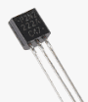` 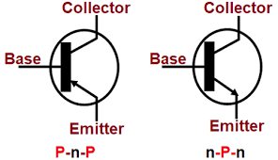
Figure 5: Transistor Transistor Symbol

5. A buzzer or beeper is an audio signaling device, which may be mechanical, electromechanical, or piezoelectric. Typical uses of buzzers and beepers include alarm devices, timers, and confirmation of user input such as a mouse click or keystroke.
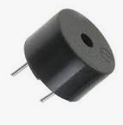
Figure 6: Buzzer Buzzer Symbol
The 555 timer IC is an integrated circuit used in a variety of timer, delay, pulse generation, and oscillator applications. Derivatives provide two or four timing circuits in one package. The design was first marketed in 1972 by Signetics. [13] , Last https://www.explainthatstuff.com/howrelayswork.html retrieved 5-May-

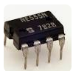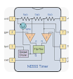
Figure 7: 555Timer IC
Internal schematic
The internal block diagram and schematic of the 555 timer are highlighted with the same color across all three drawings to clarify how the chip is implemented:^{[2]}
- Voltage Divider: Between the positive supply voltage V_{CC} and the ground GND is a voltage divider consisting of three identical resistors, which create two reference voltages at ¹⁄₃ V_{CC} and ²⁄₃ V_{CC}. The latter is connected to the "Control" pin. All three resistors have the same resistance, 5 kΩ for bipolar timers, 100 kΩ (or higher) for CMOS timers.
- Threshold Comparator: The comparator's negative input is connected to the higher reference voltage divider of ²⁄₃ V_{CC} (and "Control" pin), and the comparator's positive input is connected to the "Threshold" pin.
- Trigger Comparator: The comparator's positive input is connected to the lower reference voltage divider of ¹⁄₃ V_{CC}, and the comparator's negative input is connected to the "Trigger" pin.
- Flip-Flop: An SR flip-flop stores the state of the timer and is controlled by the two comparators. The "Reset" pin overrides the other two inputs, thus the flip-flop (and therefore the entire timer) can be reset at any time.
- Output: The output of the flip-flop is followed by an output stage with push-pull (P.P.) output drivers that can load the "Output" pin with up to 200 mA for bipolar timers, lower for CMOS timers.
- Discharge: Also, the output of the flip-flop turns on a transistor that connects the "Discharge" pin to the ground.
- 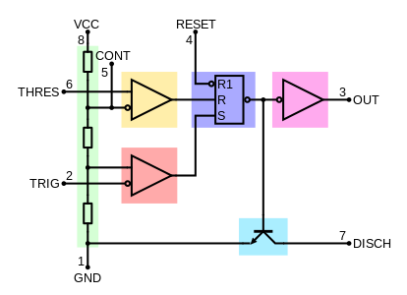
Figure 8: 555 internal block diagram
How It Works, Internal Schematic and Block Diagram
Let’s take a closer look what’s inside the 555 Timer and explain how it works in each of the three modes. Here’s the internal schematics of 555 Timer which consists of 25 transistors, 2 diodes and 15 resistors. [15] , 2018. Retrieved https://en.wikipedia.org/wiki/Internalblockdiagram 8-May-2018.
Represented with a block diagram it consists of 2 comparators, a flip-flop, a voltage divider, a discharge transistor and an output stage.
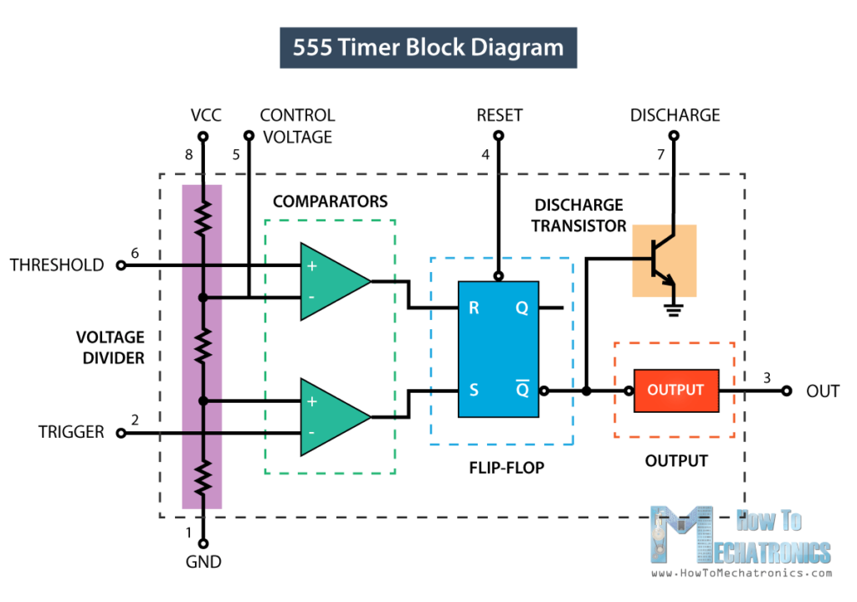
Figure 9: Block Diagram
The voltage divider consists of three identical 5k resistors which create two reference voltages at 1/3 and 2/3 of the supplied voltage, which can range from 5 to 15V.
PINS OF 555 TIMER
The pinot of the 8-pin 555 timer and 14-pin 556 dual timer are shown in the following table. Since the 556 is conceptually two 555 timers that share power pins, the pin numbers for each half is split across two columns.
In the following table, longer pin names are used, because manufacturers never standardized the abbreviated pin names across all datasheets. [16] http://what-when-how.com/8051-PINS of555timer/time-delay-for-various-

555 pin# | Pin name | Pin direction | Pin description
1 | GND | Power | Ground supply: this pin is the ground reference voltage (zero volts).
2 | TRIGGER | Input | Trigger: when the voltage at this pin falls below ¹⁄₂ of the voltage of CONTROL (¹⁄₃ V_{CC}, except when CONTROL is driven by an external signal), the OUTPUT goes to the high state and a timing interval starts. As long as this pin continues to be kept at a low voltage, the OUTPUT will remain in the high state.
3 | OUTPUT | Output | Output: this pin is a push-pull (P.P.) output that is driven to either a low state (GND) or a high state (for bipolar timers, V_{CC} minus approximately 1.7 volts) (for CMOS timers, V_{CC}). For bipolar timers, this pin can drive up to 200 mA, but CMOS timers are able to drive less (varies by chip). For bipolar timers, if this pin drives an edge-sensitive input of a digital logic chip, a 100 to 1000 pF decoupling capacitor (between this pin and GND) may need to be added to prevent double triggering.
4 | RESET | Input | Reset: a timing interval may be reset by driving this pin to GND, but the timing does not begin again until this pin rises above approximately 0.7 volts. This pin overrides TRIGGER, which in turn overrides THRESHOLD. If this pin is not used, it should be connected to V_{CC} to prevent electrical noise accidentally causing a reset.
5 | CONTROL | Input | Control: this pin provides access to the internal voltage divider (²⁄₃ V_{CC} by default). By applying a voltage to this pin, the timing characteristics can be changed. In astable mode, this pin can be used to frequency-modulate the OUTPUT state. If this pin is not used, it should be connected to a 10 nF decoupling capacitor (between this pin and GND) to ensure electrical noise doesn't affect the internal voltage divider.
6 | THRESHOLD | Input | Threshold: when the voltage at this pin is greater than the voltage at CONTROL (²⁄₃ V_{CC} except when CONTROL is driven by an external signal), then the OUTPUT high state timing interval ends, causing the OUTPUT to go to the low state.
7 | DISCHARGE | Output | Discharge: For bipolar timers, this pin is an open-collector (O.C.) output, CMOS timers are open-drain (O.D.). This pin can be used to discharge a capacitor between intervals, in phase with the OUTPUT. In bistable mode and schmitt trigger mode, this pin is unused, which allows it to be used as an alternate output.
8 | V_{CC} | Power | Positive supply: For bipolar timers, the voltage range is typically 4.5 to 16 volts, some are spec'ed for up to 18 volts, though most will operate as low as 3 volts. For CMOS timers, the voltage range is typically 2 to 15 volts, some are spec'ed for up to 18 volts, and some are spec’d as low as 1 volt. See the supply min and max columns in the derivatives table in this article. Decoupling capacitor(s) are generally applied (between this pin and GND) as a good practice.

6. Vero board is a brand of strip board, a pre-formed circuit board material of copper strips on an insulating bonded paper board which was originated and developed in the early 1960s by the Electronics Department of Vero Precision Engineering Ltd (VPE). It was introduced as a general-purpose material for use in constructing electronic circuits - differing from purpose-designed printed circuit boards (PCBs) in that a variety of electronic circuits may be constructed using a standard wiring board.
The first single-size Vero board product was the forerunner of the numerous types of prototype wiring board which, with worldwide use over five decades, have become known as strip board. Use as with other strip boards, in using Vero board, components are suitably positioned and soldered to the conductors to form the required circuit. Breaks can be made in the tracks, usually around holes, to divide the strips into multiple electrical nodes enabling increased circuit complexity.
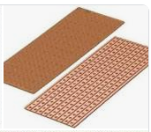
Figure10: Vero-board
This type of wiring board may be used for initial electronic circuit development, to construct prototypes for bench testing or in the production of complete electronic units in small quantity.
Vero board was first used for prototype construction within Vero Electronics Department in 1961. The images of a binary decade counter sub-unit clearly show both the assembled components and the copper conductors with the required discontinuities.
7. Switch In electrical engineering, a switch is an electrical component that can disconnect or connect the conducting path in an electrical circuit, interrupting the electric current or diverting it from one conductor to another. The most common type of switch is an electromechanical device consisting of one or more sets of movable electrical contacts connected to external circuits. When a pair of contacts is touching current can pass between them, while when the contacts are separated no current can flow.
The types of switches are classified into four types namely:
- SPST (Single Pole Single throw)
- SPDT (single pole double throw)
- DPST (double pole, single throw)
- DPDT (double pole double throw)
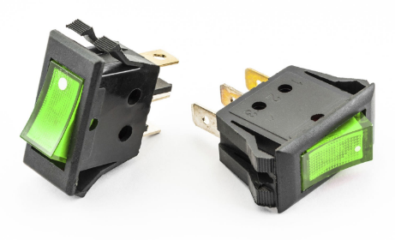
Figure 11: Switch bottom Switch Symbol

Reference
[11] http://www.pic-control.com/rain-sensor, 7-April-2015.
[12] , Retrieved https://learn.sparkfun.com/tutorials/transistors 6-May-2018.
[13] , Last https://www.explainthatstuff.com/howrelayswork.html retrieved 5-May-2018.
[14] https://www.engineersgarage. com/electronic-components/16x2-lcd-module-datasheet. Last retrieved 7-May-2018.
[15] , 2018. Retrieved https://en.wikipedia.org/wiki/Veroboard 8-May-2018.
[16] http://what-when-how.com/8051-microcontroller/time-delay-for-various-8051-chips/. Retrieved 8-May-2018.

CHAPTER FOUR
TEST, RESULTS AND ANALYSIS
4.1 TEST AND RESULT
The reliability and functionality tests of this device was carried out to know how reliable the system is. Though there is a delay in both the time taken to open and time taken to close to be able to work efficiently and prevent the effect of torque on the motor and the device at large [17] Prabhakar Hegade,
4.2 DICUSSION OF RESULTS
The system signaled the user first before it actually started to rain thereby giving the user ample time to retrieve/recover valuable items and preventing them from being wetted by rain water. [18] Imran Ahmed Khan, Khushboo Gupta, (2015) “Design of Rain Detection Result. The time here refers to recovery time and it is the foundation of this design. It is deduced that the protector opens when it confirms that there is water on the board and closes when there is no more water.
4.3 Testing/evaluation after construction
This is a physical observation of the whole system when it's on the operational stage. It includes the following:
1. Cross checking the whole circuit arrangement and ensuring that the connections are in order as well as the soldering.
2. The circuit was also cross checked for short circuit and open circuit at various lines and points of connections and there is no any fault identified.
3. The circuit was connected to the supply, after connecting the circuit to the supply and power switched was "ON" for about 30-60 seconds and it was observed that there were no any physical abnormalities.
4. The circuit is also switch ON for about 3 minutes, each component was cross checked for overheating and the system was found normal.
4.3. Discussion of Results
The main reason for testing all the components before they were finally soldered on the Vero-board is to avoid the painstaking effort it will take to dis-solder faulty components at the end of the day. [19] https://www.mepits. com/product/691rainalarmresult discussion//89s52-a. From the continuity test carried out on the vero-board to check the circuit path, it was discovered that the circuit was in a perfect working condition as continuity was ensured. Simulation of the circuit design was also done as mentioned earlier, with the sole objective of comparing the results obtained from design calculations to that obtained from simulation. The two results when compared closely correspond with only a very slight discrepancy in values.

References
[1] O. J. Bedrij, “Carry-select adder,” IRE Trans. Electron. Comput, pp. 340–344, 1962.
[2] B. Ramkumar, H.M. Kittur, and P. M. Kannan, “ASIC implementation of modified faster carry save adder,” Eur. J. Sci. Res., vol. 42, no. 1, pp.53–58, 2010. [3] T. Y. Ceiang and M. J. Hsiao, “Carry-select adder using single ripple carry adder,” Electron. Lett., vol. 34, no. 22, pp. 2101–2103, Oct. 1998.
[4] J. M. Rabaey, Digtal Integrated Circuits— A Design Perspective Upper Saddle River, NJ: Prentice-Hall, 2001
[5] J. M. Rabaey, Digtal Integrated Circuits— A Design Perspective Upper Saddle River, NJ: Prentice-Hall, 2001.
[6] Y. He, C. H. Chang, and J. Gu, “An area efficient 64-bit square root carry-select adder for lowpower applications,” in Proc. IEEE Int. Symp. Circuits Syst., 2005, vol. 4, pp. 4082–4085.
[7] Cadence, “Encounter user guide,” Version 6.2.4, March
[8] Oyubu A.O, (2017) “design and implementation of a rain water detector-larm system ” International Journal of Advancements in Research & Technology, Vol 4, Issue 6, June .
[9] Hashim N.M.Z, Husin S.H, Ja’afar A.S & Hamid N.A.A, (2013)“ International Journal of Application Smart Wiper Control System” or Innovation in ngineering & Management Vol. 2 Pp. 409-415.
[10] Rain sensor https//www.azosensors.com/equipment-category. aspx?cat=34. Last retrieved 5-May-2018.
[11] http://www.pic-control.com/rain-sensor, 7-April-2015.
[12] , Retrieved https://learn.sparkfun.com/tutorials/transistors 6-May-2018.
[13] , Last https://www.explainthatstuff.com/howrelayswork.html retrieved 5-May-2018.
[14] https://www.engineersgarage. com/electronic-components/16x2-lcd-module-datasheet. Last retrieved 7-May-2018.
[15] , 2018. Retrieved https://en.wikipedia.org/wiki/Veroboard 8-May-2018.
[16] http://what-when-how.com/8051-microcontroller/time-delay-for-various-8051-chips/. Retrieved 8-May-2018.
[17] Prabhakar Hegade, Sunil Nayak, Parashuram Alagundi, Kiran M R, (2016) “ ” International Automatic Protection of Clothes from Rain Journal of Advanced Research in Computer and Communication Engineering Vol. 5, Issue 4.
[18] Imran Ahmed Khan, Khushboo Gupta, (2015) “Design of Rain Detection System for Power Windows ” International Journal of Advanced Research in Computer Science and Software Engineering 5(4), pp. 1523-1527.
[19] https://www.mepits. com/product/691/microcontrollers/89s52-a

